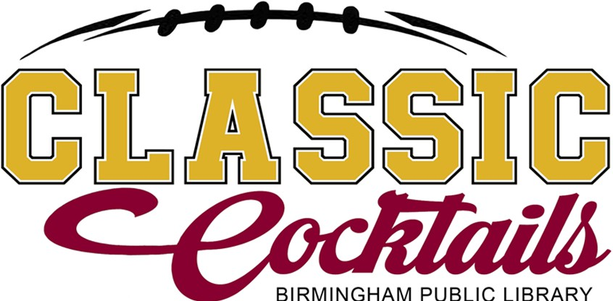 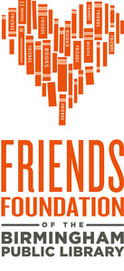

**About the Event:** The Birmingham Public Library (BPL) and the Friends Foundation of BPL are excited to announce our 3rd annual *Classic Cocktails,* a Magic City Classic Kickoff Party. Classic Cocktails will take place on Tuesday, October 22, 2024, from 5:30 to 9 p.m., at downtown's Central Library. The event will feature specialty cocktails, food, music, a cigar lounge and more.

**About BPL:** The mission of the Birmingham Public Library is to provide the highest quality experience to our community for lifelong learning, cultural enrichment and enjoyment.

**About the Friends Foundation of BPL:** The Friends Foundation of the Birmingham Public Library is an independent 501(c)(3) tax-qualified, non-profit organization. It operates both independently and in partnership with BPL and others to fulfill its mission of supporting the programs, services, and partnerships of BPL through advocacy, outreach, and fundraising. Working closely with BPL staff, the Friends Foundation helps the Birmingham Public Library be the best library it can be.

# Sponsorship Opportunities

**Title Sponsor ($10,000)**

* Recognition at the event
* Promotion as an official Title sponsor on BPL website, social media and in event coverage
* Tickets to the event

**Field Goal Sponsor ($1,000)**

* Recognition at the event
* Promotion as an official event sponsor on BPL website, social media and in event coverage
* Tickets for 8 guests

**Signature Sponsor ($5,000)**

* Recognition at the event
* Promotion as an official Signature sponsor on BPL website, social media and in event coverage
* Tickets for 15 guests

**Safety Goal Sponsor ($500)**

* Recognition at the event
* Promotion as an official event sponsor on BPL website, social media and in event coverage
* Tickets for 6 guests

__ **Team Player Sponsor ($100)**

* Tickets for 2
* Recognition at the event

**Touchdown Sponsor ($2,000)**

* Recognition at the event
* Promotion as an official sponsor on BPL website, social media and in event coverage
* Tickets for 10 guests

# Sponsorship Agreement

Contact Name: Company Name: Address: City: State: Zip: _ Phone: Email:

**Payment Method:** Check. Please make check payable to the Friends Foundation of the Birmingham Public Library.

Credit/Debit/PayPal. Please visit [www.friendsofthebpl.org.](http://www.friendsofthebpl.org/)

*Please send your company logo to* [*chandler.champion@cobpl.org*](mailto:chandler.champion@cobpl.org) *no later than Friday, September 27th. For more information, contact Chandler Champion by email or phone at* 205-226-3613*.*